Experiment Title**.** Create a class with a method that prints "This is parent class" and its subclass with another method that prints "This is child class". Now, create an object for each of the class and call

1 - method of parent class by object of parent class

2 - method of child class by object of child class

3 - method of parent class by object of child class

Student Name: Sandeep Singh UID:19BCS4555

Branch: CSE-IOT Section/Group1/B

Semester: 4th Date of Performance:23-04-21

Subject Name: programming in python lab Subject Code:CSP-287

**1. Overview of Virtual Box:** Jupyter notebook

**2. Tasks to be done:**

Create a class with a method that prints "This is parent class" and its subclass with another method that prints "This is child class". Now, create an object for each of the class and call

1 - method of parent class by object of parent class

2 - method of child class by object of child class

3 - method of parent class by object of child class

**3. Steps for practical**: (Mention the steps for each and every task)

Step1: create two classes one is parent and other is child

Step2: define method in each class

Step3: using print function write according to the question

Step4: create object of each class

Step5: call the methods using these objects

**4. Screenshots:**

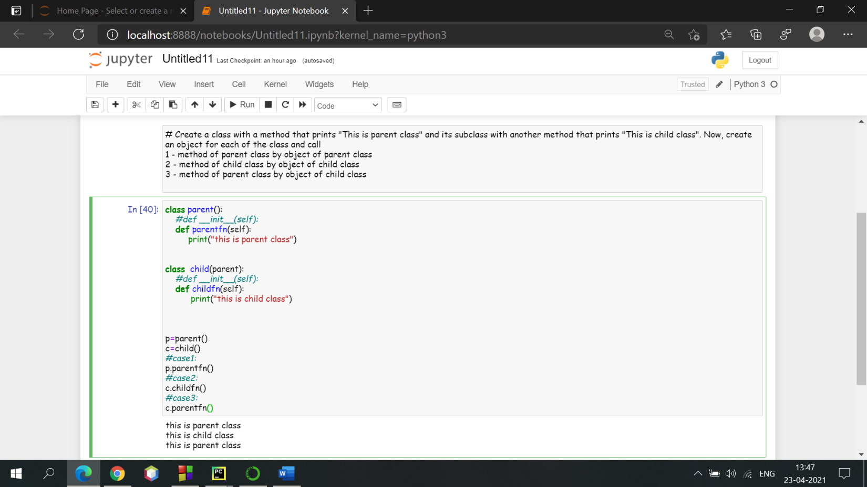

**5. Commands used:**

class parent():

def parentfn(self):

print("this is parent class")

class child(parent):

def childfn(self):

print("this is child class")

p=parent()

c=child()

#case1:

p.parentfn()

#case2:

c.childfn()

#case3:

c.parentfn()

**6. Result/Output/Writing Summary:**

OUTPUT:-

this is parent class

this is child class

this is parent class

**Learning outcomes (What I have learnt):**

1. I have learnt the concept of classes and object

2. I have learnt the concept of inheritance

3. I have learnt how to call method

**Evaluation Grid (To be created as per the SOP and Assessment guidelines by the faculty):**

|  |  |  |  |
| --- | --- | --- | --- |
| Sr. No. | Parameters | Marks Obtained | Maximum Marks |
| 1. |  |  |  |
| 2. |  |  |  |
| 3. |  |  |  |
|  |  |  |  |